The White Lion Inn
Bar – Dining – Accommodation
Christmas Party Menu 2017
Available from Friday 1st December until Saturday 23rd December

To Start
Sweet potato and lentil soup with croutons and homemade bread
Crispy aromatic duck, cucumber, spring onion, mini pancakes and hoisin sauce
Home cured beetroot, gin and pink peppercorn Mere trout gravadlax with a horseradish crème fresh and rye bread
Devilled mushrooms on toasted ciabatta

Mains
Traditional roast turkey with clementine stuffing and pigs in blankets
Pan fried fillet of pork with spiced apple compote and a cider sauce
Sautéed strips of beef in a wholegrain mustard and whisky sauce with rice
Local venison, red wine, thyme and chestnut casserole
Smoked haddock rarebit with roasted tomatoes
Chestnut mushroom, Camelot blue cheese and port topped with puff pastry

Puddings
Traditional plum pudding with brandy sauce
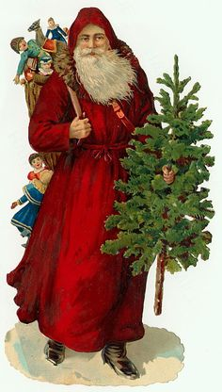
Ginger and lemon lovely with brandy snap twirls topped with a Christmas hat
(a ‘lovely’ is a traditional Dorset pudding)
Pear poached in mulled wine with sorbet
Cointreau and Belgian chocolate mousse with chocolate orange ice cream
Mini cheeseboard of west country cheese

2 courses £20.50 3 courses £25.50
£5 non-refundable deposit required per person at time of booking
Please contact us on any dietary requirements and children’s menu

